**JKUAT-KSA Small Scale Agriculture Crop Mapping Project**

**Field Work Report**

**OBJECTIVES**

* To collect validation data for the small scale crop mapping project. To compare the initial classification of Sentinel-2 and Landsat 8 imagery with the actual ground data.
* To collect detailed crop attribute information and confirm user needs to aid in the development of the web and mobile application in the small scale crop mapping project.
* To learn mobile GIS, and visualize the application and integration of office work with field practice.

**INTRODUCTION**

Storage of information in the Small Scale Crop Mapping Project (SSCM) has been done on individual PCs through simple formats of lines, points, polygons and basic attribute information. For example, initial classification on the GEE platform. Google Earth Pro has been used to seek general information about the selected study area including the geographical extent, urban areas, identifying the area under cropland and scouting various regions of Nyandarua County, which served as a reconnaissance. Most of the work had been done remotely, with land cover classification on the Google Earth Engine Platform and user needs speculation without direct contact with the farmers and collection of real-time data.

The field work exercise played a major role in understanding the extent of Nyandarua County, its climatic conditions, the nature of small scale farming in the county, and validation of the initial land cover classes developed from the Sentinel-2 satellite imagery on the Google Earth Engine Platform. Mobile GIS was widely used in this exercise. It involves the use of mobile phones and PDAs with installed GIS Software. Some of the installed software applications are extensions of desktop GIS, although users continue to take mobile GIS data and upload it directly to powerful visualization tools online such as Google Earth. Mobile GIS allows for simplified methods of data collection and editing in the field, at a high accuracy and limited time. Many mobile GIS systems are relatively inexpensive.

**Mobile GIS and the SW Maps Application**

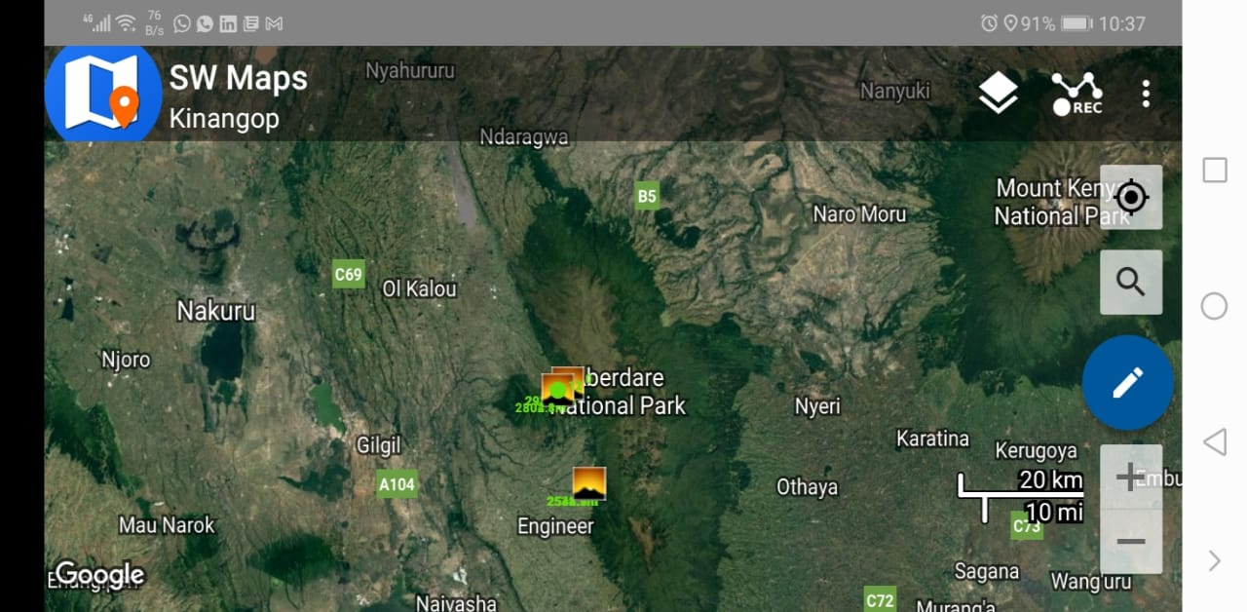

The field work exercise started with selection of a few points from the classification data and a reconnaissance on Google Earth Pro. A field route was decided upon, and optimized to achieve an optimal route to visit all selected points with minimum cost and travel time. This involved analyzing the road network by considering the traffic volume, type of roads, width of roads and number of turns within the suggested roads. Attribute information about the growth and progress of each crop and farming methods used was collected through sampling different farms, conducting farmer interviews and recording the information gathered on mobile phones and tablets. The SW maps application was particularly useful in the creation, management and collection of GIS data within the “Kinangop Project”, developed within the app. The students were able to capture, store, update, manipulate, analyze, and display geospatial data and information in the field. GPS enabled tablets with wireless communications for Internet-based GIS access were used to pick GPS points throughout the fieldwork exercise and collection of validation data.

The SW Maps application used in SSCM fieldwork project is a free GIS and mobile mapping app that allows one to collect, store, present, and share geographic data. Points, lines, areas, and photographs can be captured and shown on a custom background map, and custom attribute information can be added to every feature. Text, numbers, preset options, photos, audio samples, and videos are all examples of properties that can be incorporated in the SW Maps program.

External RTK capable sensors are used to execute high-accuracy GPS surveys and to put markers on the map for drawing features and measuring area and distance. The collected data can be saved on the device storage or exported as whole projects, KMZ layers, or shapefiles. Users can also collaborate on projects.

Some of the reasons why the SW maps application was suitable for the field work exercise include:

* Availability of online Base maps such as Google Maps, Google Terrain and Open Street Map
* The application supports multiple MB tiles and KML overlays.
* It is possible to create a variety of feature layers with separate sets of custom properties.
* Templates can be re-used or shared.
* GPS tracks can be recorded and distances measured on the app.
* Features can be drawn on the map and saved as KMZ, Shapefiles, or Geo JSON files.
* Attribute values can be used to label features.
* Feature layers can be imported from existing projects or templates.
* Sharing or exporting collected data as KMZ (photos included), shapefiles, or Geo JSON can be done.
* Folders can be created on the SD card root and copied to the appropriate directories to load MB Tiles, KML, shapefiles, and Geo JSON from an external SD card.

**PROCEDURE AND DATA ANALYSIS**

1. Reconnaissance

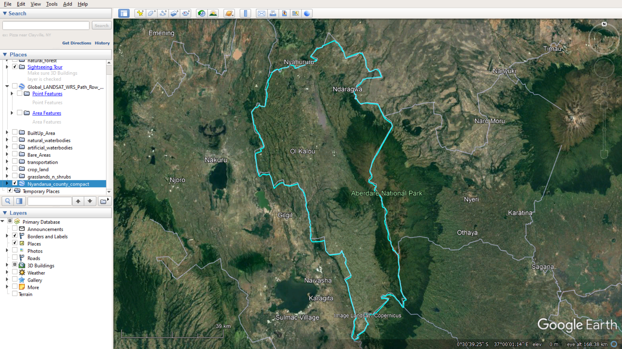

A brief reconnaissance was done via Google Earth Pro to acquire basic information about the desired study area. Google Earth has tools for drawing points, lines, and polygons, as well as distance and area measuring tools. For basic cartography work and easy reconnaissance of a region, Google Earth is a feasible solution. The number of available sources of data in Google Earth, as well as the number of data centers that have been incorporated, is remarkable. Google Earth offers a wealth of background information and presentation and direct feature data concerning the object of interest. Google Earth could be a valuable learning tool for map enthusiasts. The following information was gathered from Google Earth Pro and literature review research.

* Approximate Area of Nyandarua County: 3,304 km2.
* Capital: Ol Kalou
* Geographical Extent.
* Latitudinal extent: between 0o 09’ N and 0 o 57’ S of the Equator
* Longitudinal extent: between 36o 06’E and 36 o 52’ E of the Prime Meridian.
* Electoral constituencies: Kinangop, Kipipiri, Ol’ Kalou, Ol Jorok and Ndaragua.
* Subcounties in Nyandarua: Ol'Kalou, Kinangop, Kipipiri, Ndaragwa and Ol'Joro Orok
* Wards in Kinangop Constituency: Gathara, Murungaru, North Kinangop and Githabai.
* Urban Areas within Nyandarua County: Ol Kalou, Engineer, Ndunyu Njeru, Murungaru Shopping Center, Gwathukia, Kwa Haraka Trading Center, Kirima Shopping Center, Karangatha Shopping Center, among others.
* Nyandarua county borders Nakuru County to the West, Kiambu County to the South, Murang'a and Nyeri counties to the East and Laikipia County to the North.

It was discovered that agriculture was the main economic activity in Nyandarua County. Most of the farming activities were done in Kinangop electoral constituency, and much of the land in South Kinangop was under crop type cover. The project team had previously settled on South Kinangop for this reason.

1. Data Collection via the SW Maps Application
2. Creation of the “Kinangop” project on the Application

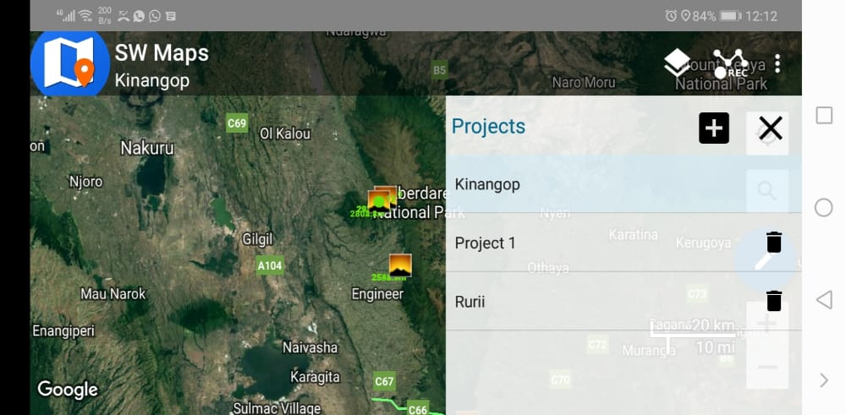

1. Taking of GPS points at every cropland portion maintained on the farms.
2. Creation of farm attribute records including:

* Planting and harvesting dates
* Farming methods used: whether the farms were rain-fed or irrigated, and whether crop rotation was practiced.
* Type of irrigation used, such as overhead irrigation, drip irrigation or direct manual application
* Type of fertilizer or manure used, application dates and frequency
* Input and anticipated crop yields in kilograms
* Additional inputs such as poles used to suspend some crops
* Total cost of production and anticipated profit gains
* Pests and diseases affecting the crops
* Additional challenges experienced by the farmers
* The percentage of farmers with access to smart phones, laptops and internet connection
* Farmer reviews about the web and mobile application prototypes

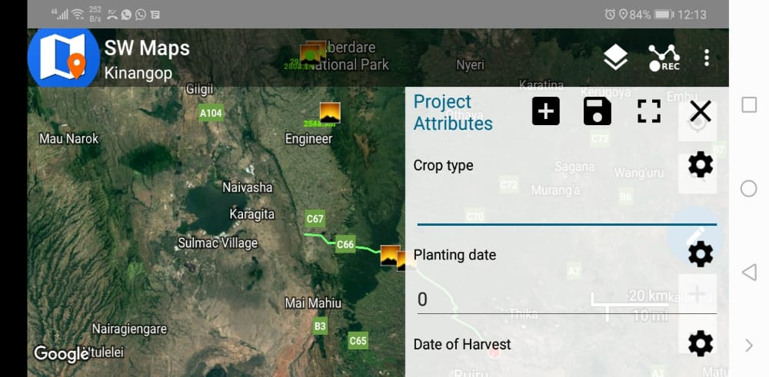

1. Location information in terms of latitude, longitude, elevation and time of collecting the information was automatically captured by the application.
2. Taking photographs of the crops grown on the farms.
3. Determination of farming methods such as mixed crop farming.
4. Determinations of the plot size in terms of hectares or acres by asking the farmers or pacing.
5. Type of irrigation being used in the farm and the type of fertilizers being used at each stage of growth of the crops was determined by asking the farmers, reading farm records or reading farm placards.
6. Detailed field notes of the farming methods, attributes and challenges were recorded by a team member.
7. Exporting the project as KMZ and Shapefiles for manipulation within the Google Earth Pro and Google Earth Engine Respectively.

The sampled output of a feature on the exported project on Google Earth Pro is shown below:

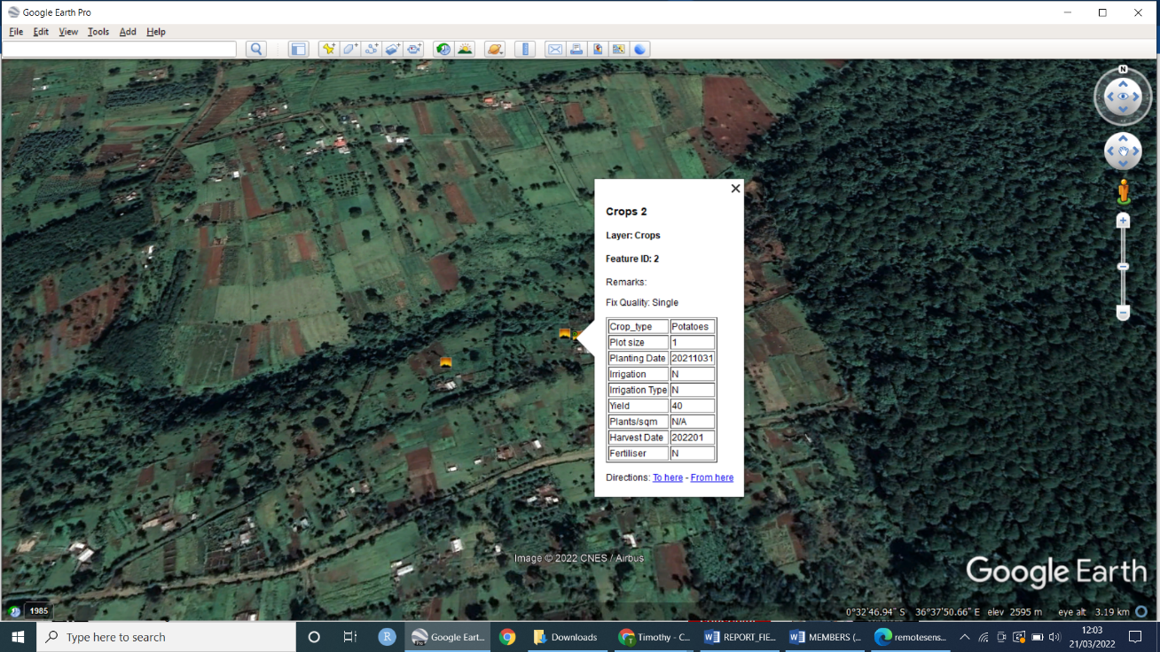

1. Data Analysis

* The average size of the farms was between 0.25 acres – 3 acres, which satisfies the average size of small holder farms in Kenya.
* Crops grown on the farms included: potatoes, peas, maize, cabbages, carrots and flowers (such as Scabiosa and Yellow Arum Lilies). Tree tomatoes and spring onions were also grown on smaller scales, and appeared healthy.
* Most of the farms were irrigated crop lands while a few were rainfed agricultural farms. Crops grown under irrigation were healthier than rain-fed crops.

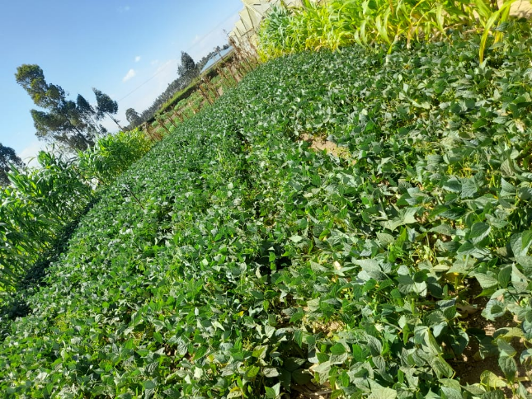

* The types of irrigation observed on the farms included overhead irrigation, direct manual application and drip irrigation.
* Irrigation was mostly done on the windward sides of the hills, where water was more readily available. Overhead irrigation was used by most farmers. Irrigation was mostly done in the mid-morning and late evening.
* Overhead irrigation caused significant water loss. However, most farmers could not install drip irrigation systems due to high initial and maintenance costs, ignorance, or the slope of the land.
* Most of the farmers did not keep proper farming records.
* Spring Onions were mainly grown for local consumption, and did not require application of fertilizers or pesticides.
* Farming was done on the slopes of hills as well as flat land, depending on the soil type. Grass was planted on the steep sloping farms to reduce soil erosion.
* The most common soil type was loam soil, as estimated by the farmers and the team.
* Only few farmers were visited by agricultural extension officers, and therefore had little information concerning the state of farms, especially in the remote areas. They wished to have increased farm visits from the extension officers.
* A significant percentage of the farmers had access to smart phones and the internet. They wished to acquire more information about farming practices, improving their farming methods, increasing yield and the nature of the markets in and out of their locality.
* White flies, aphids, snails and caterpillars were reported by the farmers as the pests affecting the crops.

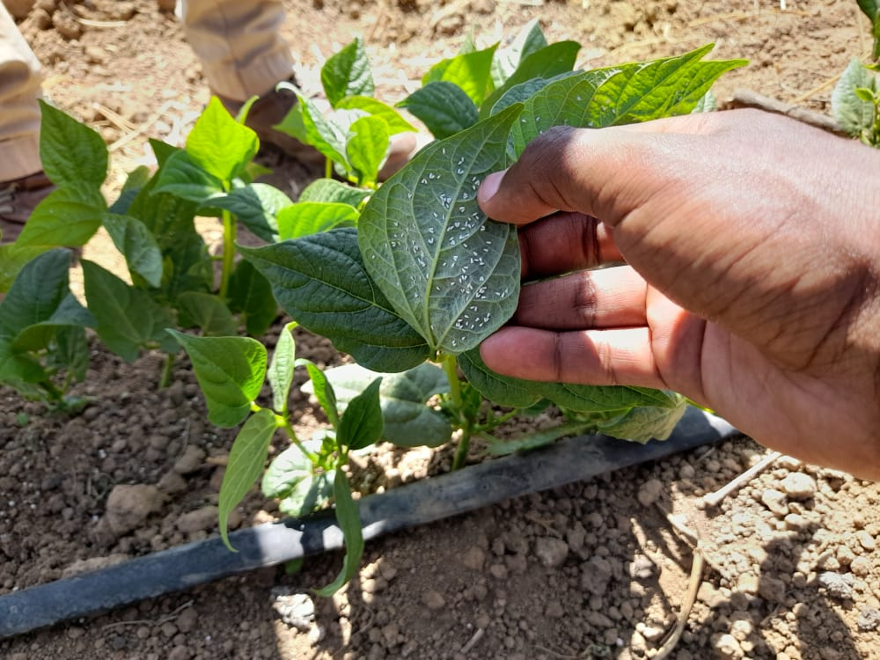

Challenges Experienced by Farmers

* Access to ready market was a challenge to the farmers. Production of similar goods at the local market lowered unit prices for the farm produce, leaving the farmers with very little profit.
* Transport to the existing local market was also a major challenge to the farmers. Some of the farms were located in very remote areas, and the poor road networks leading to these areas could impair the quality of the produce. Transport was majorly via motorcycles, which posed very high costs to the farmers.
* Due to the existing transport challenge, most farmers sold their farm produce to middle men who purchased the agricultural products at very low prices, which was frustrating to the farmers.
* Government Policies such as standardization of weight in potato packaging from 130kg to 50kg sent away buyers. This caused huge losses on the farmers’ side.
* Unpredictable climatic conditions caused major losses to the farmers. Some of the crops on the rain-fed farms dried up from inadequate rainfall.
* High cost of farm inputs such as fertilizers was discouraging to the farmers.
* The irrigated farms were infested with snails which were a major challenge to the farmers on the windward slopes of the hills.

Challenges experienced by the team during the Fieldwork exercise

* Dehydration due to long exposure to high intensity sunshine for long hours.
* Language barrier: some team members could not understand the farmers’ local dialect

CONCLUSION

Data collection using SW application was an interactive process where farm photographs were captured together with their attribute information for validation. Data collection was done by interviewing the farmers working on the farms, and collection of GPS points for each crop grown in the farms visited by the team. The field work exercise was successful, and it provided a great learning experience and exposure to Mobile GIS for all the students.

References

1. The SW Maps User Guide

<http://41.74.23.114:8000/Bioressource_mobile/SW_Maps_manual.pdf>

1. Google Earth Pro User Guide

<http://earth.google.com/intl/ar/userguide/v4/index.htm>